**WI-FI STANDARDS (IEEE 802.11)**

|  |  |
| --- | --- |
| Prepared by | Ayushi Pradhan |
| Reviewed by | V.Mamatha |

* The IEEE is probably best known for its LAN standards, the IEEE 802 project.
* IEEE projects are subdivided into working groups to develop standards that address specific problems or needs.
* For instance, the IEEE 802.3 working group was responsible for creating a standard for Ethernet, and the IEEE 802.11 working group was responsible for creating the WLAN standard.
* The numbers are assigned as the groups are formed, so the 11 assigned to the wireless group indicates that it was the 11th working group formed under the IEEE 802 project. IEEE 802.11 technology, more commonly referred to as Wi-Fi, is a standard technology for providing LAN communications using radio frequencies (RF).
* As the need arises to revise existing standards created by the working groups, task groups are formed. These task groups are assigned a sequential single letter that is added to the end of the standard number(For example, 802.11g, 802.11i, and 802.3af).
* Each Wi-Fi network standard has two parameters :
  + Speed
    - This is the data transfer rate of the network measured in Mbps (1 megabit per second).
  + Frequency
    - On what radio frequency, the network is carried on. Two bands of frequency for the Wi-Fi are 2.4 GHz and 5 GHz. In short, it is the frequency of radio wave that carries data.
    - Wi-Fi routers that come with 2.4 GHz or5 GHz are called the single-band routers, but a lot of new routers support both 2.4 GHz and 5 GHz frequency they are called dual-band routers.
    - The 2.4 GHz is a common Wi-Fi band, but it is also used by other appliances like Bluetooth devices, wireless phones, cameras, etc. Because of the signal used by so many devices, the signal becomes overcrowded, and speed becomes slow. So, 5 GHz comes into the picture, it is new, and not commonly used, and because it is used by fewer devices there is no signal crowding and interference.

|  |  |
| --- | --- |
| 2.4 GHz | 5 GHz |
| Overcrowded | Not overcrowded |
| Slow | Fast |
| Interference is more | Interference is less |
| 14 channels | 165 channels |
| 3 non overlapping channels | 24 non overlapping channels |
| Long range | Short range |
| Standards which use 2.4 GHz are 802.11, 802.11b, 802.11g, 802.11n | Standards which use 5 GHz are 802.11a, 802.11n, 802.11ac |

**Channels:**

* Essentially, Wi-Fi channels are smaller bands within Wi-Fi frequency bands that are used by your wireless network to send and receive data.
* In 2.4 GHz, 14 channels are there.
* In 5 GHz, 165 channels are there.

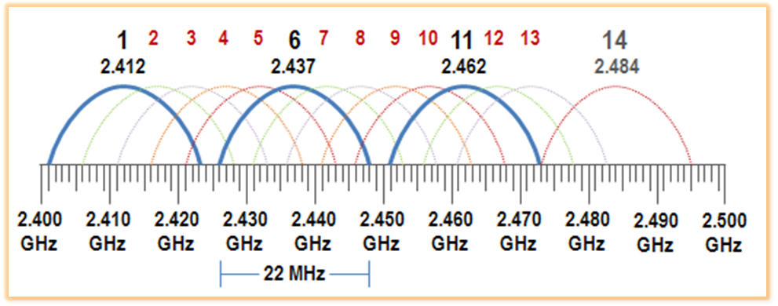

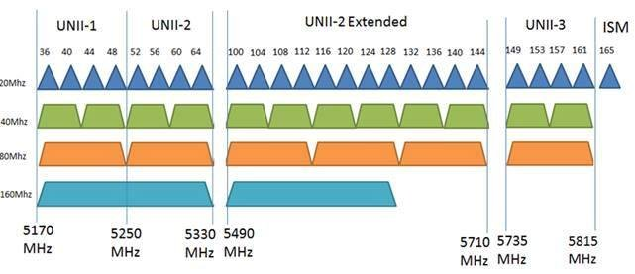

**Subcarriers:**

* A subcarrier is a secondary modulated signal frequency modulated into the main frequency (the carrier) to provide an additional channel of transmission.
* It allows for a single transmission to carry more than one separate signal.
* In 2.4 GHz, 64 subcarriers are there.
* There are three types of subcarriers
  + Data Subcarriers
  + Pilot Subcarriers
  + Unused or Reserved Subcarriers
* In 802.11 a/b/g, out of 64 subcarriers, 48 are data, 4 are pilot and 12 are reserved.
* In 802.11n, out of 64 subcarriers, 52 are data, 4 are pilot and 8 are reserved.

**TRANSMISSION TECHNIQUES**

**Narrow bandwidth signal:**

Narrowband signals occupy much less frequency spectrum and require less transmit power for a given application.

**Spread Spectrum:**

Spread Spectrum uses a lot of frequency space which helps with overcoming interference and jamming. Unlike narrowband, spread spectrum uses low power.

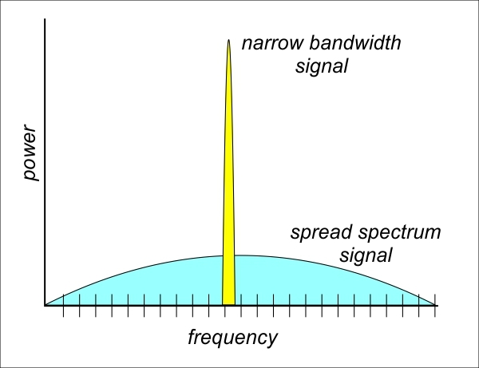

**Frequency Hopping Spread Spectrum (FHSS)**

* Frequency hopping spread spectrum works by transmitting data using a small frequency carrier space and then hops to another.
* The period of time it stays in a space is called dwell time. When the dwell time expires it moves.
* Hop time is the time between dwell times where the transmission hops to the next frequency.
* This predefined hopping pattern is known as the hopping sequence and is repeated once it reaches the end.

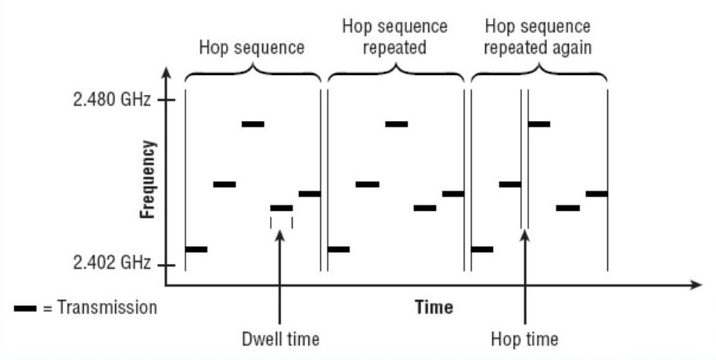

**Direct Sequence Spread Spectrum (DSSS)**

* Each bit of the user data is multiplied by a secret code, called as chipping code.
* This chipping code is nothing but the spreading code which is multiplied with the original message and transmitted.
* An 11-bit Barker code is used as the spreading sequence.
* The receiver uses the same code to retrieve the original message.
* Take as an example that the data to be transmitted is 1001, and the chip or spreading code is 0010. For each data bit, the complete spreading code is used to multiple the data, and in this way, for each data bits, the spread or expanded signal consists of four bits.

|  |  |  |  |  |
| --- | --- | --- | --- | --- |
| 1 | 0 | 0 | 1 | Data to be transmitted |
| 0010 | 0010 | 0010 | 0010 | Chip or spreading code |
| 1101 | 0010 | 0010 | 1101 | Resultant spread data output |

* With the signal obtained and transmitted, it needs to be decoded within the remote receiver:

|  |  |  |  |  |
| --- | --- | --- | --- | --- |
| 1101 | 0010 | 0010 | 1101 | Incoming CDMA signal |
| 0010 | 0010 | 0010 | 0010 | Chip or spreading code |
| 1111 | 0000 | 0000 | 1111 | Result of de-spreading |
| 1 | 0 | 0 | 1 | Integrated output |

**NB:** 1 x 1 = 0     1 x 0 = 1

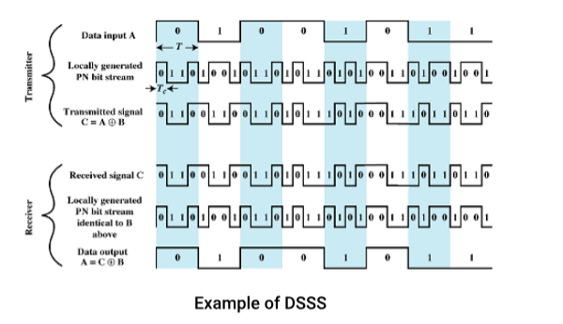

**Orthogonal Frequency Division Multiplexing (OFDM)**

* OFDM is a method of digital data modulation, whereby a single stream of data is divided into several separate sub-streams for transmission via multiple channels.
* OFDM uses the principle of frequency division multiplexing (FDM), where the available bandwidth is divided into a set of sub-streams having separate frequency bands.
* Orthogonal signals are signals that are perpendicular to each other. A main property of orthogonal signals is that they do not interfere with each other.
* When any signal is modulated by the sender, its sidebands spread out either side.
* A receiver can successfully demodulate the data only if it receives the whole signal.
* In case of FDM, guard bands are inserted so that interference between the signals, resulting in cross-talks, does not occur.
* However, since orthogonal signals are used in OFDM, no interference occurs between the signals even if their sidebands overlap. So, guard bands can be removed, thus saving bandwidth.
* In order that OFDM works, there should be very accurate synchronization between the communicating nodes. If frequency deviation occurs in the sub-streams, they will not be orthogonal anymore, due to which interference between the signals will occur.

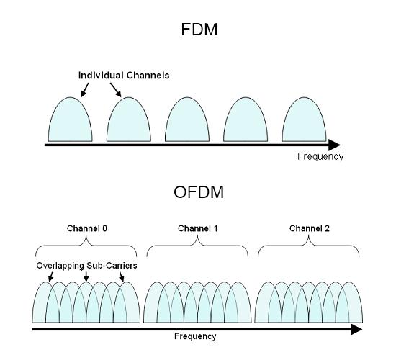

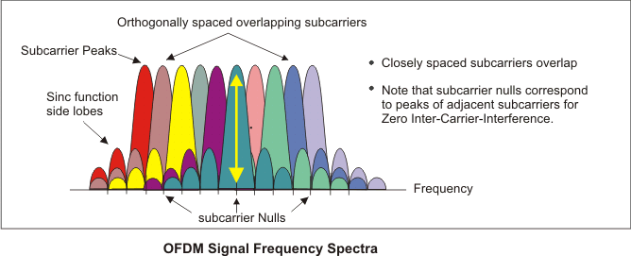

**OFDM Calculation**

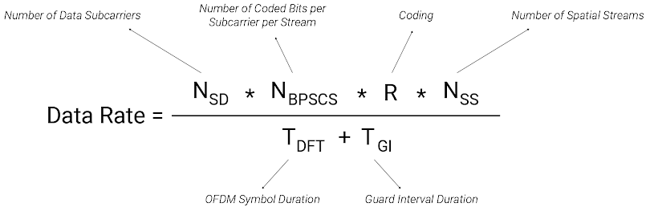

**MODULATION TECHNIQUES**

**Phase shift keying**

* A digital modulation technique that transmits data by varying the phase of the carrier wave in accordance with the digital modulating signal, is called Phase Shift Keying (PSK).
* The easiest form of PSK is BPSK i.e., binary phase shift keying. However, PSK can be extended to 4 level and 8 level PSK that totally depends on the need of the system.
* **Binary Phase Shift Keying (BPSK)**
  + In this, each signaling element is represented by a single data bit. Here, the carrier undergoes two phase reversal such as 0° and 180°.
* **Quadrature Phase Shift Keying (QPSK)**
  + QPSK can encode 2 bits per symbol (00, 01, 10, or 11) through the following four phases: 0°, 90°, 180°, and 270°. In fact, QPSK is a special type of QAM, that is, 4-QAM.

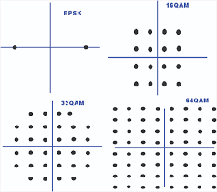

**Quadrature Amplitude Modulation (QAM)**

* QAM is a digital modulation scheme where data is transmitted over the channel by varying both the amplitude and phase of the high-frequency carrier signal.
* The transmitted signal is represented in a constellation plot that contains two axes namely the in-phase and Quadrature.
* The in-phase and Quadrature axis are separated from each other by a phase of 90˚. Therefore, these two axes are orthogonal to each other.
* Some examples include 16-QAM, 32-QAM, 64-QAM, 256-QAM, 1024-QAM.

|  |  |
| --- | --- |
| **Modulation Scheme** | **Bits/Symbol** |
| BPSK | 1 |
| QPSK / 4-QAM | 2 |
| 8-QAM | 3 |
| 16-QAM | 4 |
| 32-QAM | 5 |
| 64-QAM | 6 |
| 128-QAM | 7 |
| 256-QAM | 8 |
| 512-QAM | 9 |
| 1024-QAM | 10 |
| 2048-QAM | 11 |
| 4096-QAM | 12 |

**QAM Constellation diagram**

* On a constellation diagram, points are symmetrically distributed in a square grid. The number of constellation points in the grid determines the number of bits carried in each symbol. The following lists two typical QAM examples:
* 256-QAM: 256 is the 8th power of 2, so each symbol can carry 8-bit data.
* 1024-QAM: 1024 is the 10th power of 2, so each symbol can carry 10-bit data.

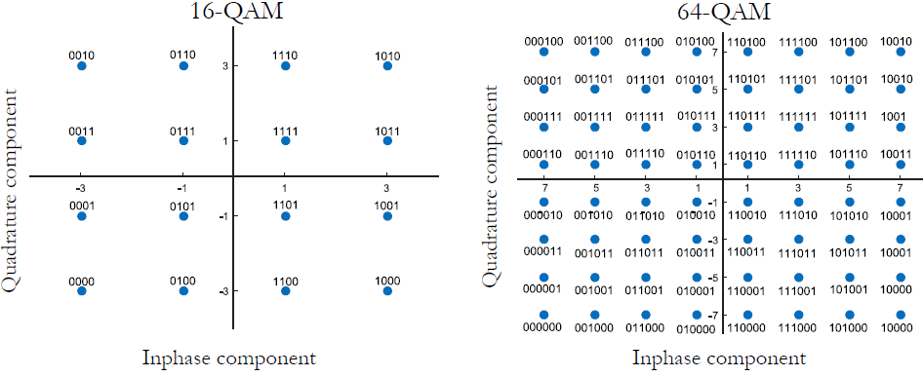

**SISO Vs MIMO**

* SISO stands for single input single output. In SISO system only one antenna is used at transmitter and one antenna is used at Receiver.
* MIMO stands for Multiple Input Multiple Output multiple antennas are used at transmitter and receiver.

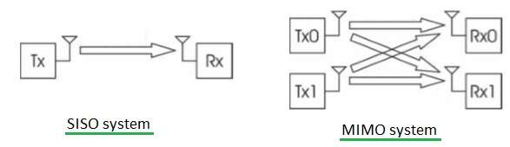

* SU-MIMO stands for Single User MIMO. An AP can communicate with only one user at a time.
* MU-MIMO, an AP can concurrently communicate with multiple users.

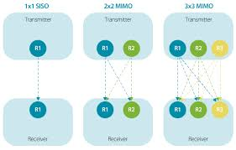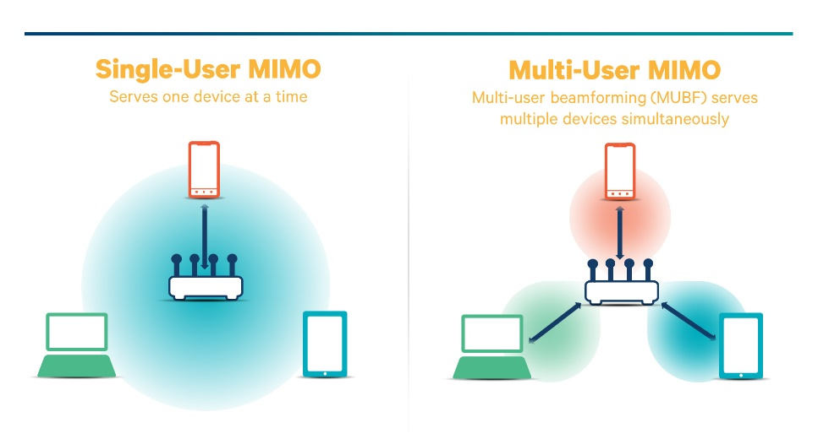

**Beamforming**

Beamforming is a technique that focuses a wireless signal towards a specific receiving device, rather than have the signal spread in all directions, like from a broadcast antenna. The resulting direct connection is faster and more reliable than it would be without beamforming.

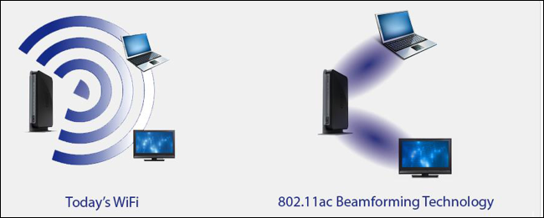

**802.11 STANDARDS**

**IEEE 802.11**

* It was developed in 1997.
* Data rates are 1 and 2 Mbps.
* It is operated in 2.4 GHz.
* Transmission technique used is FHSS/DSSS.
* It uses a bandwidth of 22MHz.

**IEEE 802.11b**

* This standard also created with 802.11a in 1999.
* The difference is that it uses a 2.4 GHz frequency band.
* Data rates are 1, 2, 5.5, 11 Mbps.
* This standard is useful for home and domestic use.
* Transmission technique used is DSSS.
* It uses a bandwidth of 22MHz.

**IEEE 802.11a**

* This standard is developed in 1999.
* 802.11a is useful for commercial and industrial purposes.
* It works on a 5 GHz frequency.
* Data rates are 6, 9, 12, 18, 24, 36, 48, 54 Mbps.
* This standard was made to avoid interference with other devices which use the 2.4 GHz band.
* Transmission technique used is OFDM.
* It uses a bandwidth of 20MHz.

**IEEE 802.11g**

* This standard is designed in 2003.
* It supports backward compatibility to 802.11b hardware.
* The frequency band used in this is 2.4 GHz for better coverage.
* Data rates are 6, 9, 12, 18, 24, 36, 48, 54 Mbps.
* Transmission technique used is OFDM.
* Even though 802.11g operates in the same frequency band as 802.11b, it can achieve higher data rates because of its better modulation from 802.11a.
* Of the 52 OFDM subcarriers, 48 are for data subcarriers with a carrier separation of 0.3125 MHz (20 MHz/64).
* Each of these subcarriers can be a BPSK, QPSK, 16-QAM or 64-QAM.
* Coding rate is ½, ¾, 2/3.
* The total bandwidth is 20MHz.

**IEEE 802.11n**

* This was introduced in 2009.
* 802.11n operates on both 2.4 GHz and 5 GHz frequency bands, they are operated individually.
* Transmission technique used is OFDM.
* It uses 64 QAM modulation.
* High throughput field is added to MAC header increasing its size to 36 bytes.
* Block acknowledgement is introduced.
* WMM power save and U-APSD is there.
* RIFS (Reduced IFS) was introduced and is used only when Block ACK is enabled.
* Of the 64 OFDM subcarriers, 52 are for data subcarriers, 4 are pilot and 8 are reserved.
* Multiple-input multiple-output (MIMO) is introduced.
* This standard allows up to four spatial streams.
* It is operated on 20MHz and 40 MHz channels.
* Channel bonding of two 20MHz channels making it to 40MHz channel.
* Frame aggregation is introduced. MPDU or A-MPDU is sent.
* It supports coding rate of ½, ¾, 2/3, 5/6.
* Guard interval was reduced from 800 nanoseconds to 400 nanoseconds.
* The data rate is around 600 Mbps.
* An 802.11n network can achieve 72 megabits per second (on a single 20 MHz channel with one antenna and 400 ns guard interval); 802.11n's speed may go up to 150 megabits per second by using two 20 MHz channels in 40 MHz mode. If more antennas are used, then 802.11n can go up to 288 megabits per second in 20 MHz mode with four antennas, or 600 megabits per second in 40 MHz mode with four antennas and 400 ns guard interval.

**IEEE 802.11ac**

* This standard was introduced in 2013.
* It uses 5 GHz band.
* Transmission technique used is OFDM.
* Maximum data rate is 6.9 Gbps.
* It will have the long guard interval 800 ns and 400 ns.
* Beamforming is introduced.
* Two phases are involved in marketing 802.11ac: 802.11ac Wave 1 and 802.11ac Wave 2.

|  |  |  |
| --- | --- | --- |
| **Item** | **802.11ac Wave 1** | **802.11ac Wave 2** |
| Band | 5 GHz | 5 GHz |
| MIMO | Single User (SU) | Multiuser (MU) |
| Channel width | 20, 40, and 80 MHz | 20, 40, 80, 80+80, and 160 MHz |
| Modulation | 256QAM | 256QAM |
| Spatial streams | 3 | 4 |
| PHY rate | 1.3 Gbps | 3.47 Gbps |

* **Features of 802.11ac Wave 1**
  + It adds 80MHz channel bandwidth.
* It improves single user MIMO
* It supports three spatial streams.
* It supports only A-MAC Protocol Data Unit Aggregation (A-MPDU).
* **Features of 802.11ac Wave 2**
  + Wave 2 supports adjacent and non-adjacent 160 MHz channel bonding.
  + It supports up to four MIMO spatial streams.
  + It uses MU-MIMO.
  + It supports A-MAC Protocol Data Unit Aggregation (A-MPDU).